Code used to build

**Step 1**

Create Directrory

mkdir -p ~/video-streaming/videos

cd ~/video-streaming

**Step 2**

Creating app.js

cat > app.js <<'EOF'

import express from "express";

import fs from "fs";

const app = express();

app.use((req, _res, next) => {

console.log(new Date().toISOString(), req.method, req.url);

next();

});

const VIDEO = process.env.VIDEO || "/videos/sample.mp4";

app.get("/video", (req, res) => {

try {

if (!fs.existsSync(VIDEO)) {

return res.status(404).send("Video file missing");

}

const stat = fs.statSync(VIDEO);

const fileSize = stat.size;

const range = req.headers.range;

if (range) {

const [startStr, endStr] = range.replace(/bytes=/, "").split("-");

const start = Number.parseInt(startStr, 10) || 0;

const end = endStr ? Number.parseInt(endStr, 10) : fileSize - 1;

if (start >= fileSize) {

res.status(416).set("Content-Range", `bytes */${fileSize}`).end();

return;

}

const chunkSize = end - start + 1;

res.writeHead(206, {

"Content-Range": `bytes ${start}-${end}/${fileSize}`,

"Accept-Ranges": "bytes",

"Content-Length": chunkSize,

"Content-Type": "video/mp4",

});

fs.createReadStream(VIDEO, { start, end }).pipe(res);

} else {

res.writeHead(200, {

"Content-Length": fileSize,

"Content-Type": "video/mp4",

});

fs.createReadStream(VIDEO).pipe(res);

}

} catch (err) {

console.error(err);

res.status(500).send("Server error");

}

});

const port = process.env.PORT || 3000;

app.listen(port, () =>

console.log(`video-streaming up on :${port}, file=${VIDEO}`)

);

EOF

Step 3

cat > package.json <<'EOF'

{

"name": "video-streaming",

"version": "1.0.0",

"main": "app.js",

"type": "module",

"dependencies": { "express": "^4.18.2" },

"scripts": { "start": "node app.js" }

}

EOF

**Step 4**

**Create Docker file**

cat > Dockerfile <<'EOF'

FROM node:18-alpine

WORKDIR /app

COPY package*.json ./

RUN npm ci --only=production

COPY . .

EXPOSE 3000

CMD ["node", "app.js"]

EOF

**Step 5**

**Create Docker compose file**

cat > docker-compose.yml <<'EOF'

services:

video-streaming:

build: .

ports:

- "3000:3000"

volumes:

- ./videos:/videos:ro

environment:

- VIDEO=/videos/sample.mp4

restart: unless-stopped

EOF

**Step 6**

**Put**any small MP4 at: ~/video-streaming/videos/sample.mp4

**Step 7**

cd ~/video-streaming

docker compose up --build -d

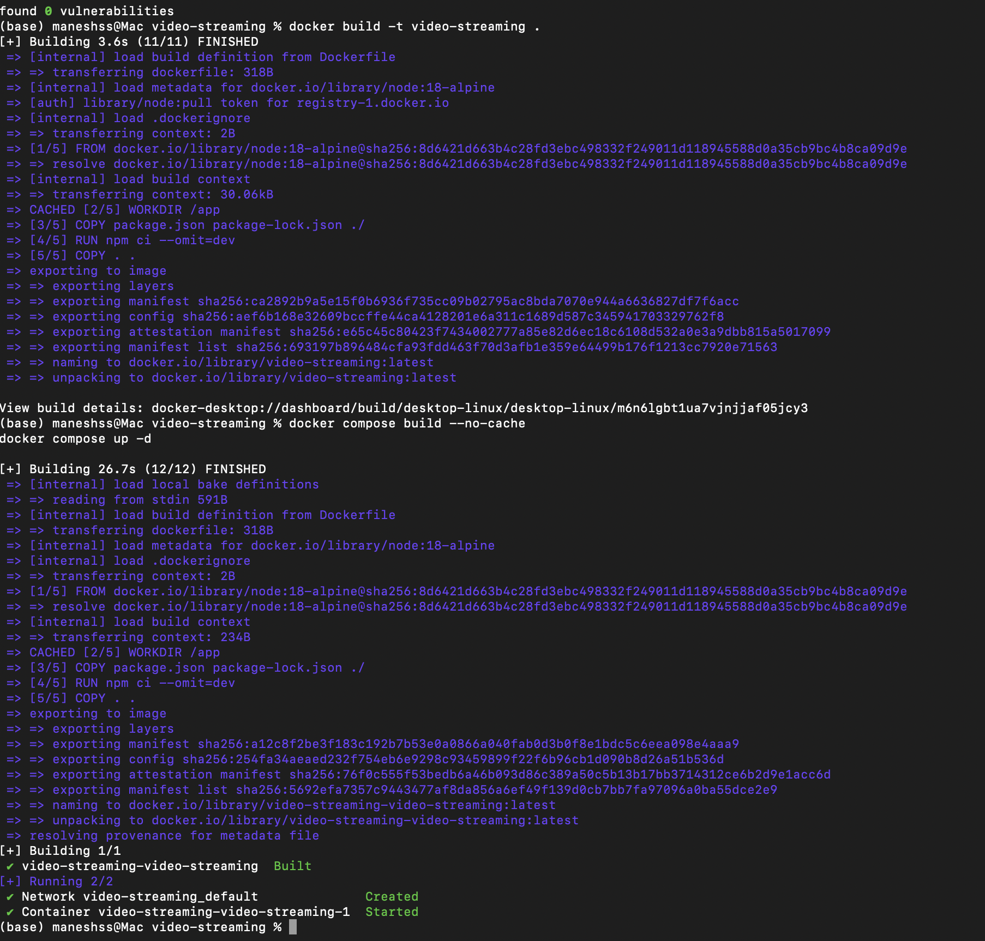

**Step 8**

docker ps --filter "name=video-streaming" --format "table {{.ID}}\t{{.Image}}\t{{.Ports}}\t{{.Names}}"



**Step 9**

Container Log

docker logs ddbfe12b94fd



**Step 10**

<http://localhost:3000/video>

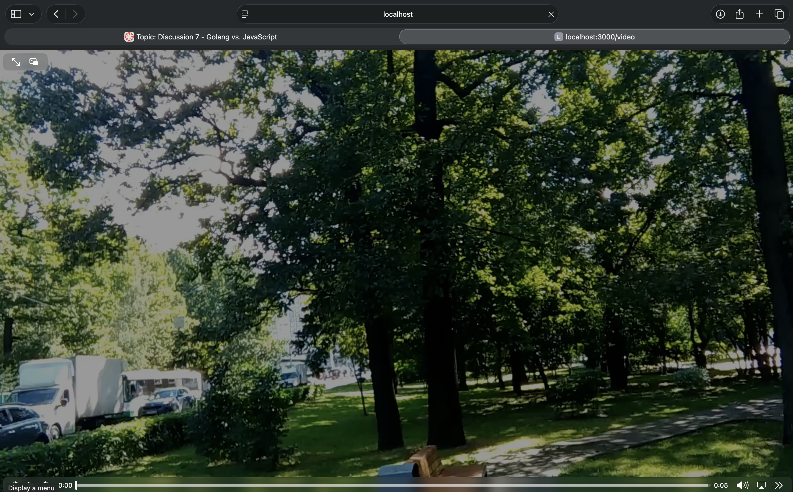

**step 11**

Docker PS

